Computer Network Lab Task 12
Name: Mahad Ashraf
Roll No: 20P-0563
Instructor: Hurmat Hidayat
Section: BSCS(5B)
The topology of our whole process is attached below. Here is the below topology which will contains all the devices that are going to be used in our system. These include switches, servers and routers. And also the PC and Laptops are also the part of this topology.
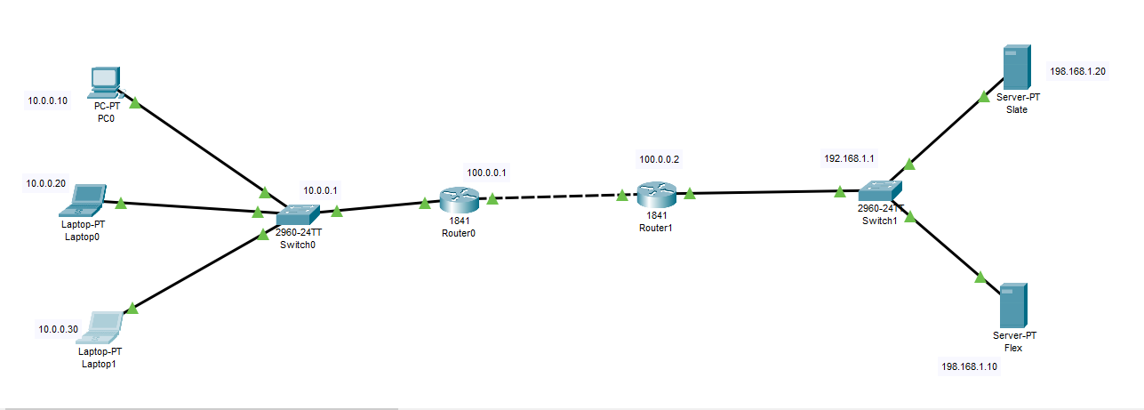.

The IP Configuration of our PC’s is mentioned below:
We are configuring all three PC’s here.
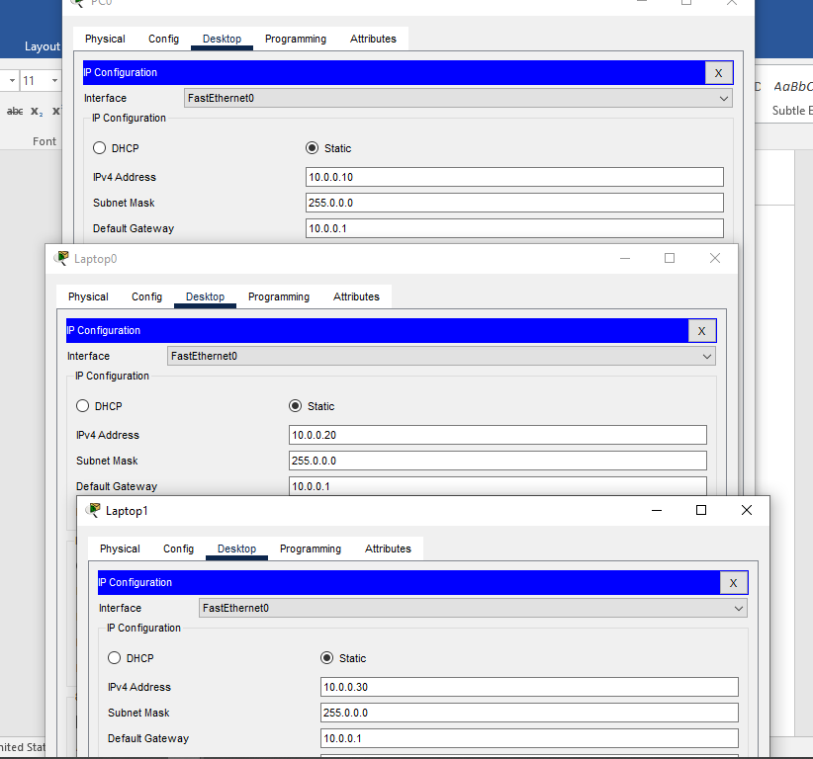.
The IP Configuration of our servers is attached below:
Here we are configuring both of the servers
IP is assigned to Flex.
IP is assigned to Slate.

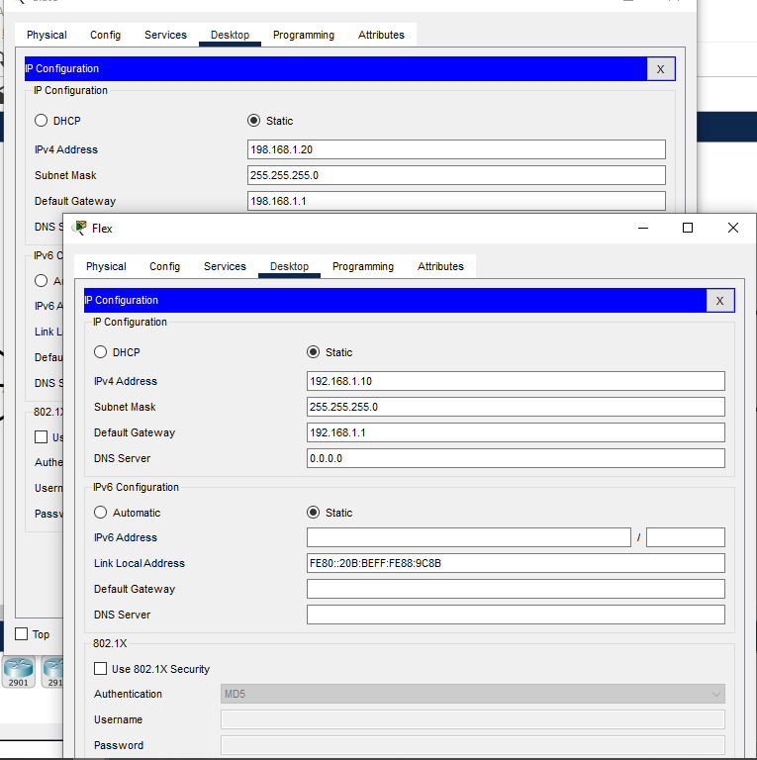.

IOS Command Line Configuration for both of the Routers is attached in the below picture.
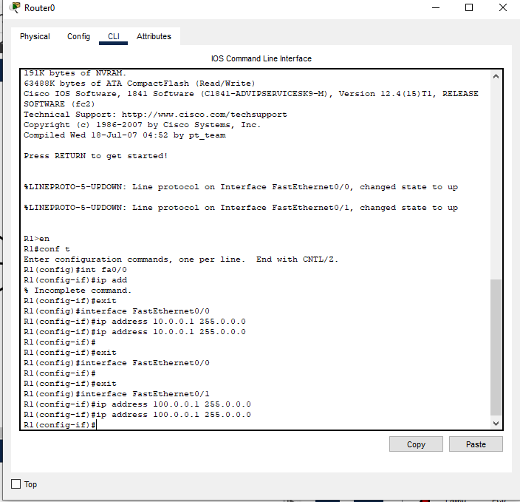
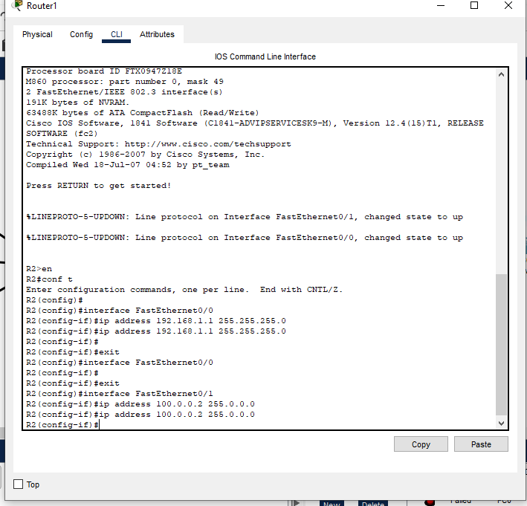

Configure Static NAT:
Here we are doing R1 Static NAT Configuration for the router 1. We will configure NAT as you can see in the Picture attached below.
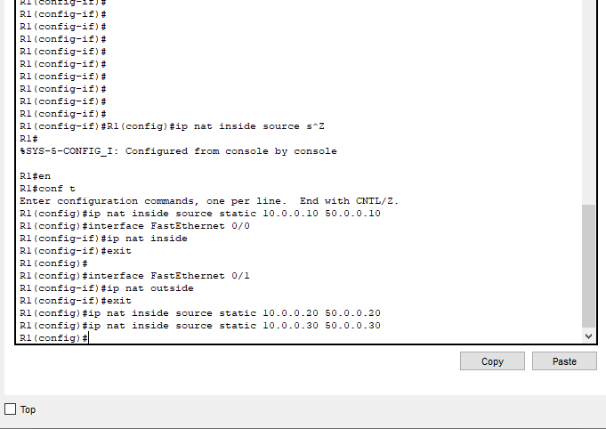

R2 Static NAT Configuration:
The Static Nat Configuration for router 2 is mentioned in the below picture. We will configure NAT as you can see in the picture attached.

To test this setup click Laptop0 and Desktop and click Command Prompt.
• Run ipconfig command.
• Run ping 200.0.0.10 command.
• Run ping 192.168.1.10 command.
We are going to perform Ping Test between various devices. So first of all we are ping from PC’s To The Servers. We have already performed the ping tests between the PCs and the both of the routers. The test was positive and we were getting response on regular intervals.

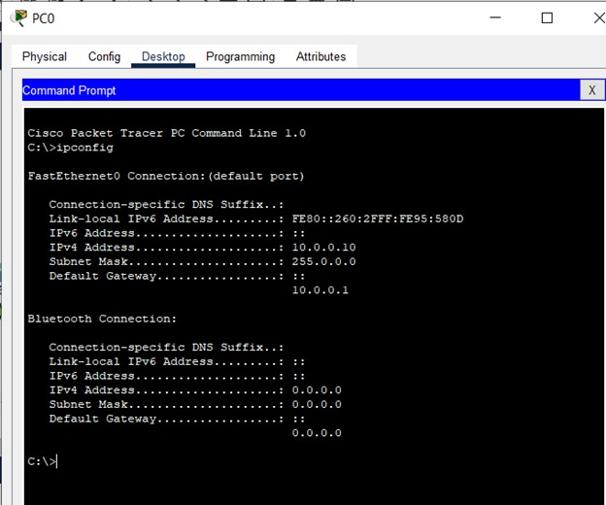
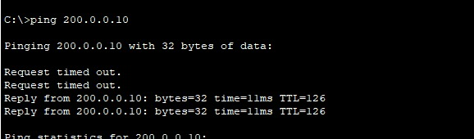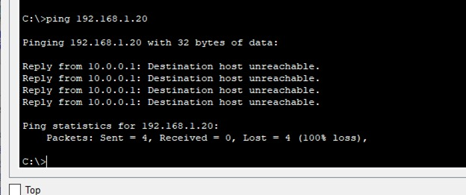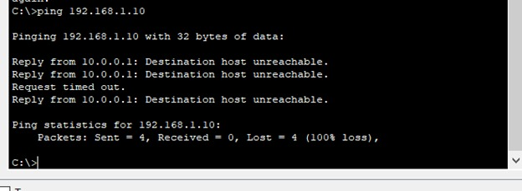Here we can see that we’ve successfully received the response of the ping test that we have performed between the PC’s. This is showing the correctness of our topology.

